**Ex No 5**

**Create tables in Hive and write queries to access the data in the table**

**AIM:**

To create tables in Hive and write queries to access the data in the table.

**PROCEDURE:**

# Download Hive and Derby

* **Apache Hive**: Download from [Hive](https://downloads.apache.org/hive/hive-3.1.3/) [Download](https://downloads.apache.org/hive/hive-3.1.3/)
* **Apache Derby**: Download from [Derby](https://db.apache.org/derby/derby_downloads.html) [Download](https://db.apache.org/derby/derby_downloads.html) Extract both .tar.gz files after downloading.

# Move Hive and Derby to /usr/local/

Open **Terminal**.

Navigate to the folder where the downloaded files are located. For example, if they are in your Downloads folder: cd ~/Downloads

Move the extracted Hive and Derby folders to /usr/local/.

For Hive:

sudo mv apache-hive-3.1.3-bin /usr/local/ For Derby: sudo mv db-derby-10.14.2.0-bin /usr/local/

Verify that the folders were successfully moved:

cd /usr/local/ ls

You should see apache-hive-3.1.3-bin and db-derby-10.14.2.0-bin listed.

# Set Environment Variables

Open your ._profile or .zshrc (depending on your shell) in a text editor. Most likely, you are using Zsh on newer macOS versions, so edit .zshrc:

nano ~/.zshrc

Add the following lines to set the environment variables for Hive and Derby:

# Set Hive environment variables export HIVE_HOME=/usr/local/apache-hive-3.1.3-bin export PATH=$PATH:$HIVE_HOME/bin

# Set Derby environment variables export DERBY_HOME=/usr/local/db-derby-10.14.2.0-bin export PATH=$PATH:$DERBY_HOME/bin

Save and exit (Ctrl + O to save, then Ctrl + X to exit).

Apply the changes by running the following command:

source ~/.zshrc

cd /usr/local/db-derby-10.14.2.0-bin/lib cp *.jar /usr/local/apache-hive-3.1.3-bin/lib/ <https://1drv.ms/f/s!ArSg3Xpur4Grmw0SDqW0g44T7HYU?e=wDsoBn>

Download all

# Move and Replace hive-site.xml

**Navigate to Hive Configuration Directory:** cd /usr/local/apache-hive-3.1.3-bin/conf

**Backup Existing hive-site.xml (if it exists):** mv hive-site.xml hive-site.xml.bak

**Copy the Downloaded hive-site.xml from Downloads:** cp ~/Downloads/hive-site.xml . **Replace the Guava Library**

**Navigate to Hive’s Libraries Directory:** cd /usr/local/apache-hive-3.1.3-bin/lib **Backup Existing Guava Library (if it exists):** mv guava-*.jar guava-*.jar.bak

**Copy the Downloaded Guava Library from Downloads:**

cp ~/Downloads/guava-*.jar .

Ensure you replace guava-*.jar with the actual filename of the Guava library you downloaded.

# Replace the Bin Folder

**Navigate to Hive Installation Directory:** cd /usr/local/apache-hive-3.1.3-bin

**Backup Existing bin Directory:**

mv bin bin.bak

**Copy the Downloaded bin Directory from Downloads:**

cp -r ~/Downloads/bin .

# Verify Installation

**Navigate to Hive’s Bin Directory:**

cd /usr/local/apache-hive-3.1.3-bin/bin **Check Hive Version to Verify Installation:**

cd /usr/local/apache-hive-3.1.3-bin/bin

chmod +x hive

# Test Hive and Derby Installation

To test if Hive is working, run:

hive --version

You should see the version of Hive that you installed.

To test if Derby is working, run:

sudo java -jar $DERBY_HOME/lib/derbyrun.jar server start You should see a message saying the Derby server started successfully.

# Start Hadoop Services (if Hadoop is Installed)

If Hadoop is set up on your system, you’ll need to start the Hadoop services for Hive to run:

Open a new terminal and go to Hadoop’s sbin directory: cd /path/to/hadoop/sbin Start the Hadoop services:

start-dfs.sh start-yarn.sh

# Configure Hive Schema with Derby

Now, initialize the Hive schema with Derby as the metastore:

Open a new terminal and run the following command to initialize the schema:

hive --service schematool -dbType derby -initSchema

# Open the Hive Shell

Now, you can open the Hive shell and start working with Hive:

Open the Hive shell by typing: hive

Verify that Hive is running correctly by creating a database and listing it:

CREATE DATABASE financials;

SHOW DATABASES;



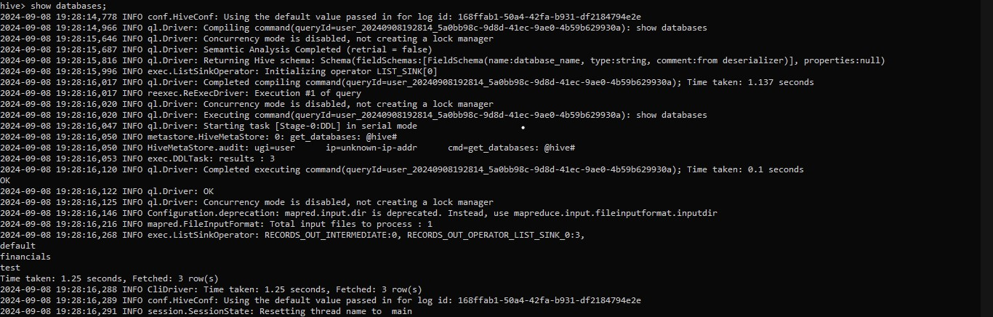

# Create a Table and Insert Data

Use the following to create a simple table in Hive:

USE financials;

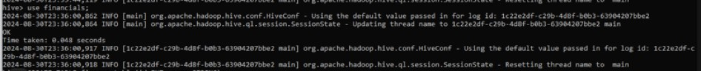

CREATE TABLE students_table (id INT, name STRING);



Insert some sample data:

INSERT INTO students_table VALUES (1, 'Alice'), (2, 'Bob'), (3, 'Charlie');

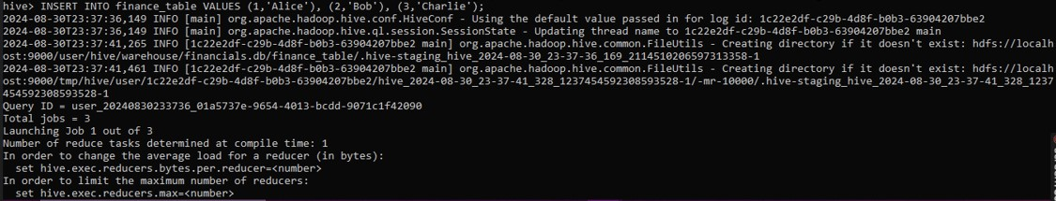

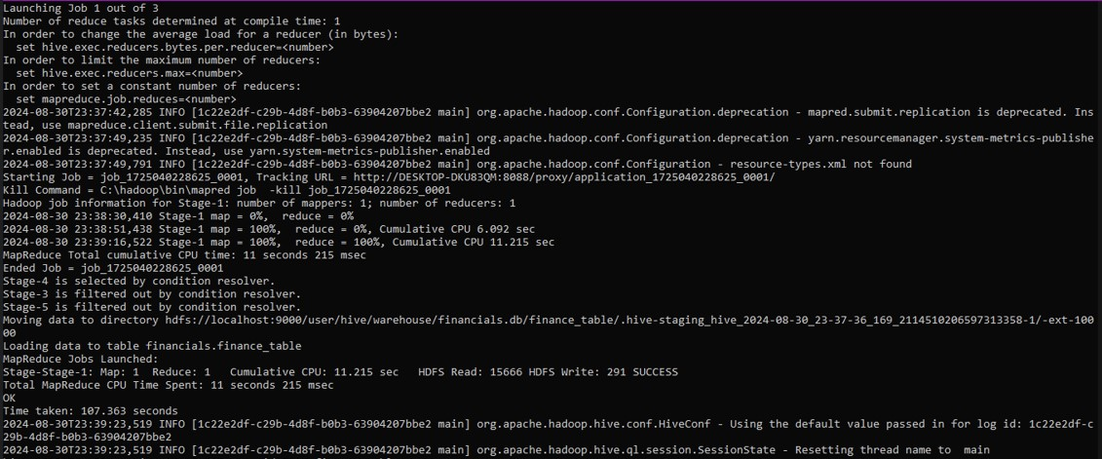

# Query the Data

Query the data to verify everything is working:

SELECT * FROM students_table;

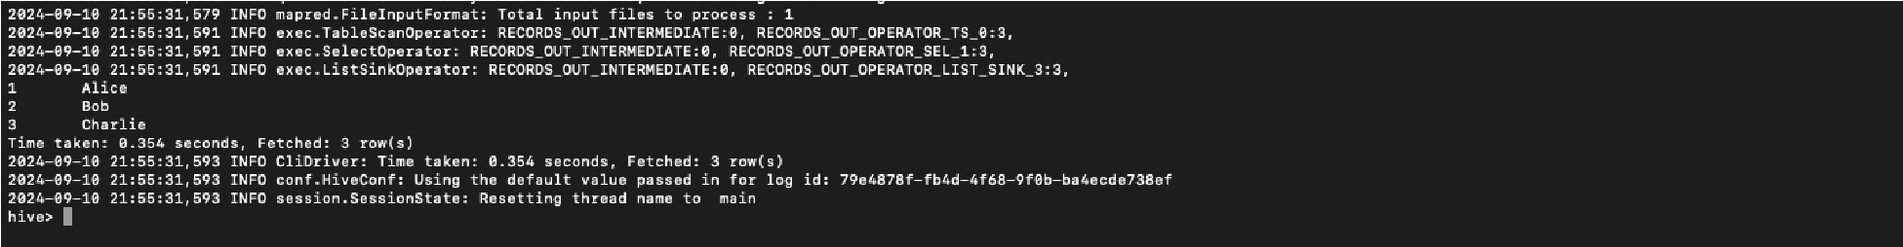

# Shut Down Hive and Derby

Exit the Hive shell by typing quit;.

Stop the Derby server by running:

sudo java -jar $DERBY_HOME/lib/derbyrun.jar server shutdown

**OUTPUT:**

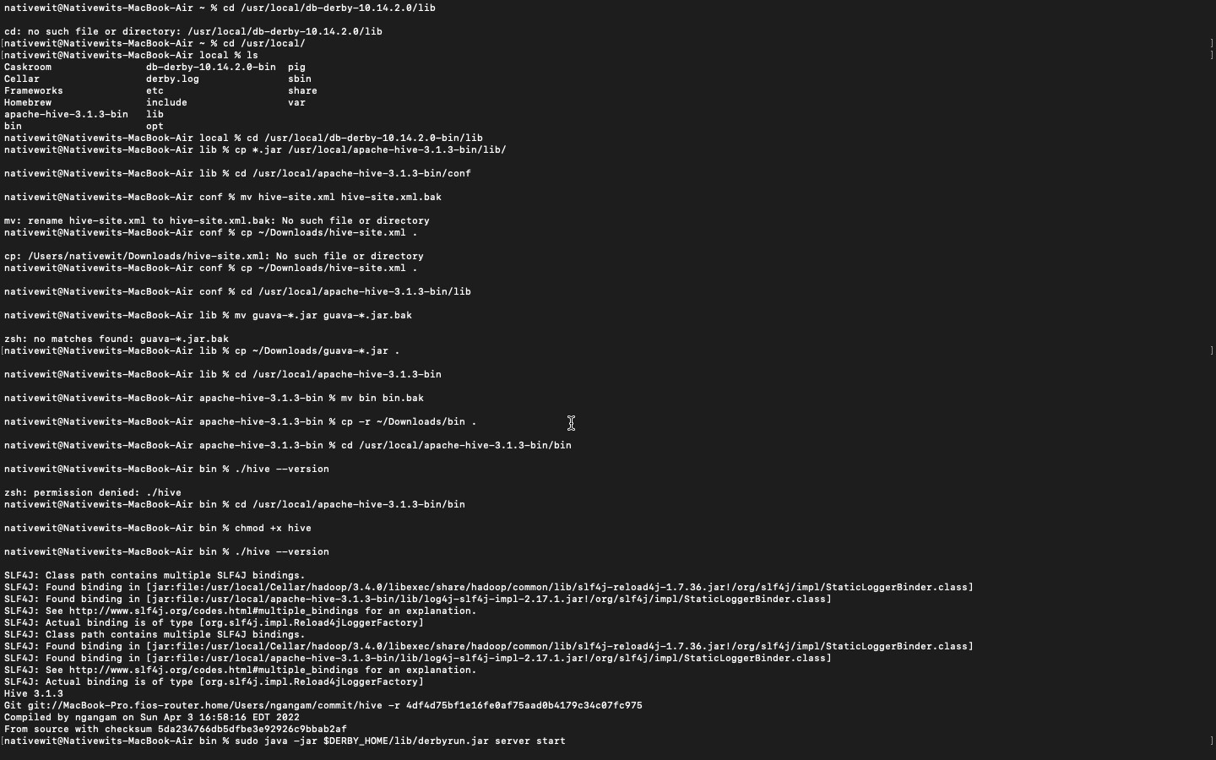

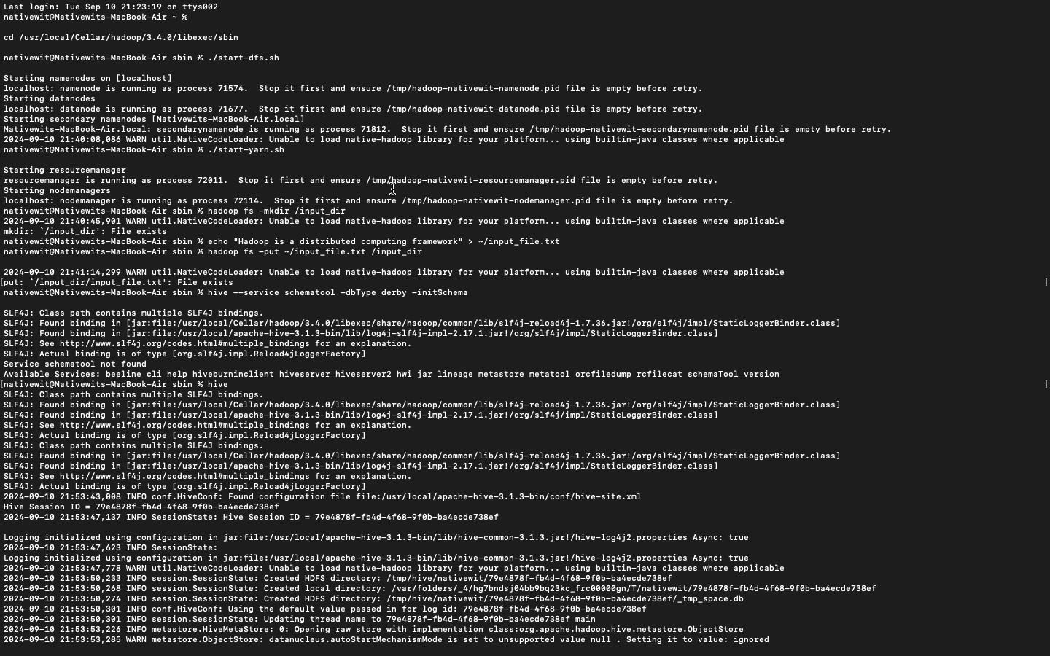

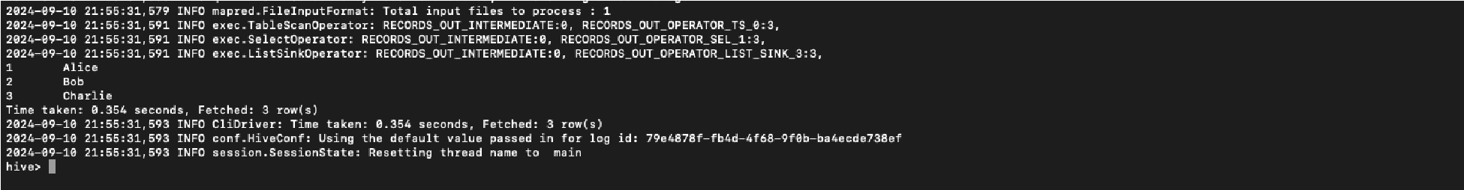

**RESULT:**

Thus, to create tables in Hive and write queries to access the data in the table was completed successfully.